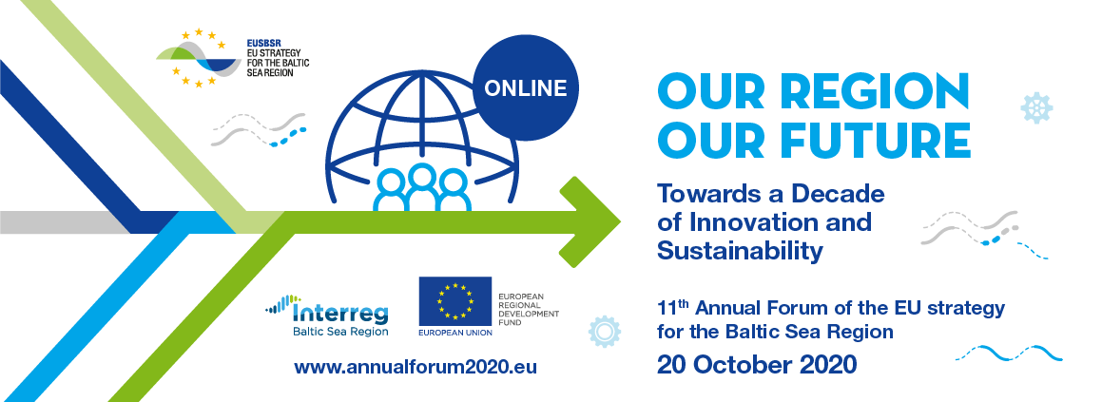 EUSBSR Annual Forum Programme

(draft of 17 September 2020)

**Tuesday 20 October 2020**

|  |  |
| --- | --- |
| **Time CEST** | **Content** |
| 09.30 – 10.00 | **Participants log-in** |
| **Moderators:**  Mr. Peter Nyman, Finnish journalist and media professional  Ms. Bettina Rafaelsen, Senior Project Manager, COWI  Mr. Esa Kokkonen, Director, The Baltic Institute of Finland |
| 10.00 - 10.30 | **OPENING SESSION**  The three objectives of the EUSBSR – ‘Save the Sea’, ‘Connect the Region’ and ‘Increase Prosperity’ should not be thought of as silos. They should be treated as interconnected and indivisible as the UN Sustainable Development Goals. For example, it is impossible to increase prosperity without truly connecting the region, and vice versa; improving ecological situation of the Baltic Sea depends heavily on the region’s prosperity, but the region cannot really prosper around the polluted sea: the examples of such connections are many. Since the EUSBSR objectives and, therefore, the EUSBSR Policy Areas are interconnected, the main philosophy of this Forum is to facilitate the creation of **innovative** multi-disciplinary teams which will tackle some of the most pressing issues from different angles, while keeping in mind overall **sustainability** of the region as the guiding principle. Prior to the Forum, the teams will gather in online workshops, which are expected to result in concrete outcomes such as policy recommendations, draft project proposals, new partnerships and consortia, etc. The EUSBSR community - already 10 years old and having developed its new Action Plan - **needs a fresh look at its achievements as well as an** **inspirational vision and the renewed political support** to guide us **Towards a Decade of Innovation and Sustainability.** During this session the EUSBSR community will be addressed by high-level speakers and will have a chance to share their views on the Strategy during the interactive breaks.    *Welcome addresses*   * *Ms. Minna Arve, Mayor, City of Turku, Finland* * *Mr. Grzegorz Poznański, Director General, Council of the Baltic Sea States Secretariat*   *Opening keynote:*   * *Ms. Tarja Halonen, former President of Finland* * *Ms. Elisa Ferreira, Commissioner, Cohesion and Reforms, European Commission (tbc)* |
| 10.30 – 11.45 | **FIRST PLENARY**  **Cooperating for Innovation and Sustainability – better together (even during a pandemic)!**  The Baltic Sea Region (BSR) countries actively cooperate on many topics and in many different constellations and formats. Do all these constellations and formats deliver the expected results in the most efficient way? The **panel will focus on BSR cooperation and what it means to cooperate effectively even when the pandemic limited the ability to meet face-to-face.** How can we maintain effective online collaboration within all three objectives of the EUSBSR? During this session distinguished panellists from different fields will provide their answers to this and other related questions while the audience will share their views and enjoy interactive, participatory breaks.  *Plenary opening keynote:*   * *Mr. Virginijus Sinkevičius, Commissioner, Environment, Oceans and Fisheries, European Commission (tbc)*   *Panel discussion:*   * *Ms. Krista Mikkonen, Minister of the Environment and Climate, Finland* * *Mr. Christos Economou, Acting Director, Directorate-General for Maritime Affairs and Fisheries, European Commission* * *Ms. Aleksandra Dulkiewicz, Mayor, City of Gdansk, Poland* * *Ms.* *Tiina Tuurnala, C.E.O., Finnish Shipowners´ Association* * *Ms. Madeleine Granvik, Director, Baltic University Programme* * *Mr. Jonas Faergeman, Chair, #ReGeneration2030 Steering Committee* |
| 11.45 – 13.00 | **Networking break** |
| 13.00 – 14.15 | **SECOND PLENARY**  **Working together, merging knowledge and skills! Emerging areas of joint, multidisciplinary actions.**  It is evident that multi-disciplinary, cross-sectorial teams deliver the most innovative results. Leading up to the Forum, a series of online workshops will be organised in cooperation between the different Policy Areas and Horizontal Actions of the EUSBSR and other relevant stakeholders. The audience will get a glimpse of how the workshops were conducted, see examples of the concrete outputs from the workshops and have an opportunity to comment and discuss the pros and cons of the proposed solutions with distinguished panellists. **The discussion will focus on the emerging areas of cooperation**. This panel will include interactive, participatory breaks for the audience.  *Plenary opening keynote:*   * *Mr. Mika Lintilä, Minister of Economic Affairs, Finland*   *Panel discussion:*   * *Mr. Tālis Linkaits, Minister for Transport, The Republic of Latvia (tbc)* * *Ms. Krystyna Wróblewska, General Secretary, Baltic Sea States Subregional Co-operation* * *Mr. Rüdiger Strempel, Executive Secretary, HELCOM* * *Ms. Christiane Mißlbeck-Winberg, Director, EU and International Affairs, Confederation of Danish Employers* * *Ms. Ülla-Karin Nurm, Director, The Northern Dimension Partnership in Public Health and Social Well-being* * *Ms. Aline Mayr, Representative, Baltic Sea Youth Platform* * *NN (tbc), Max Planck Institute* |
| 14.15 – 15.00 | **Networking break** |
| 15.00 – 16.15 | **THIRD PLENARY**  **Shaping the prosperous, competitive and sustainable future of the Baltic Sea Region – what will guide us for the next 10 years?**  The EUSBSR community strives to strengthen the Strategy´s capacity to implement itself and to adapt to the changing social, political and financial circumstances of the region. The main guiding document – the EUSBSR Action Plan – has recently been updated, but EUSBSR does not exist in vacuum, its stakeholders are also looking to global and European policies to be translated into the macro-regional joint actions. The UN SDGs and the European Green Deal are among these policies. The panel, which gathers a diverse group of experts both from within and outside the Strategy, will discuss **the future of the EUSBSR and outline the main policies that will shape the Strategy in the next 10 years.** This panel will include interactive, participatory breaks for the audience.  *Plenary opening keynote:*   * *NN (tbc), DG Regional and Urban Policy, European Commission.*   *Panel discussion:*   * *Ms. Helena Tuuri, Ambassador for Baltic Sea Affairs, Ministry for Foreign Affairs, Finland* * *Ms. Iruma Kravale, Chair of Interreg Baltic Sea Region Monitoring Committee Ministry of Environmental Protection and Regional Development, Latvia (tbc)* * *Ms. Ann Irene Sæternes, Head of European Affairs, Eastern Norway County Network* * *Mr. Risto E. J. Penttilä, C.E.O., Nordic West Office* * *Mr. Edwin Bendyk, President of the Batory Foundation, professor at the Polish Academy of Sciences Graduate School for Social Research (tbc)* * *Ms. Delara Burkhardt, Member of the European Parliament* * *NN (tbc), Russian Federation*   **CLOSING WORDS**   * *Mr. Pekka Haavisto, Minister for Foreign Affairs, Finland* |
| 16.15 | **End** |